Airline Data Management and Analysis
Using Power BI

Prepared By
Adarsh
Project Module: Data Visualization with Power BI

Introduction to the Project

This project is all about understanding and improving how airlines manage their data using Power BI. The goal is to take raw flight, passenger and ticket data and turn it into meaningful data or visuals for better understanding.
By working through the different tasks of data cleaning, modeling, creating DAX calculations, and designing visuals, I learned how airlines can use data to understand their flight performance, track passenger trends, monitor booking status, and improve overall efficiency.

Problem Statement

The airline industry operates with a lot of complex information every day, from flight schedules, passenger destinations, passenger details to bookings ticket. Handling all data manually leads to mistakes, delays, and difficulty in data understanding. To solve this issue Power BI–based analytics will be used.
This project aims to analyze airline operations for improving efficiency and customer satisfaction.

Objectives

To analyze and visualize airline data for operational insights, passenger management, and ticket booking trends using Power BI.

Tasks Overview with Screenshots

Task 1 - Data Preparation and Cleaning:
- Imported and cleaned all the datasets in Power Query.
- Removed duplicates, fixed data types and handled missing values.
Screenshots:

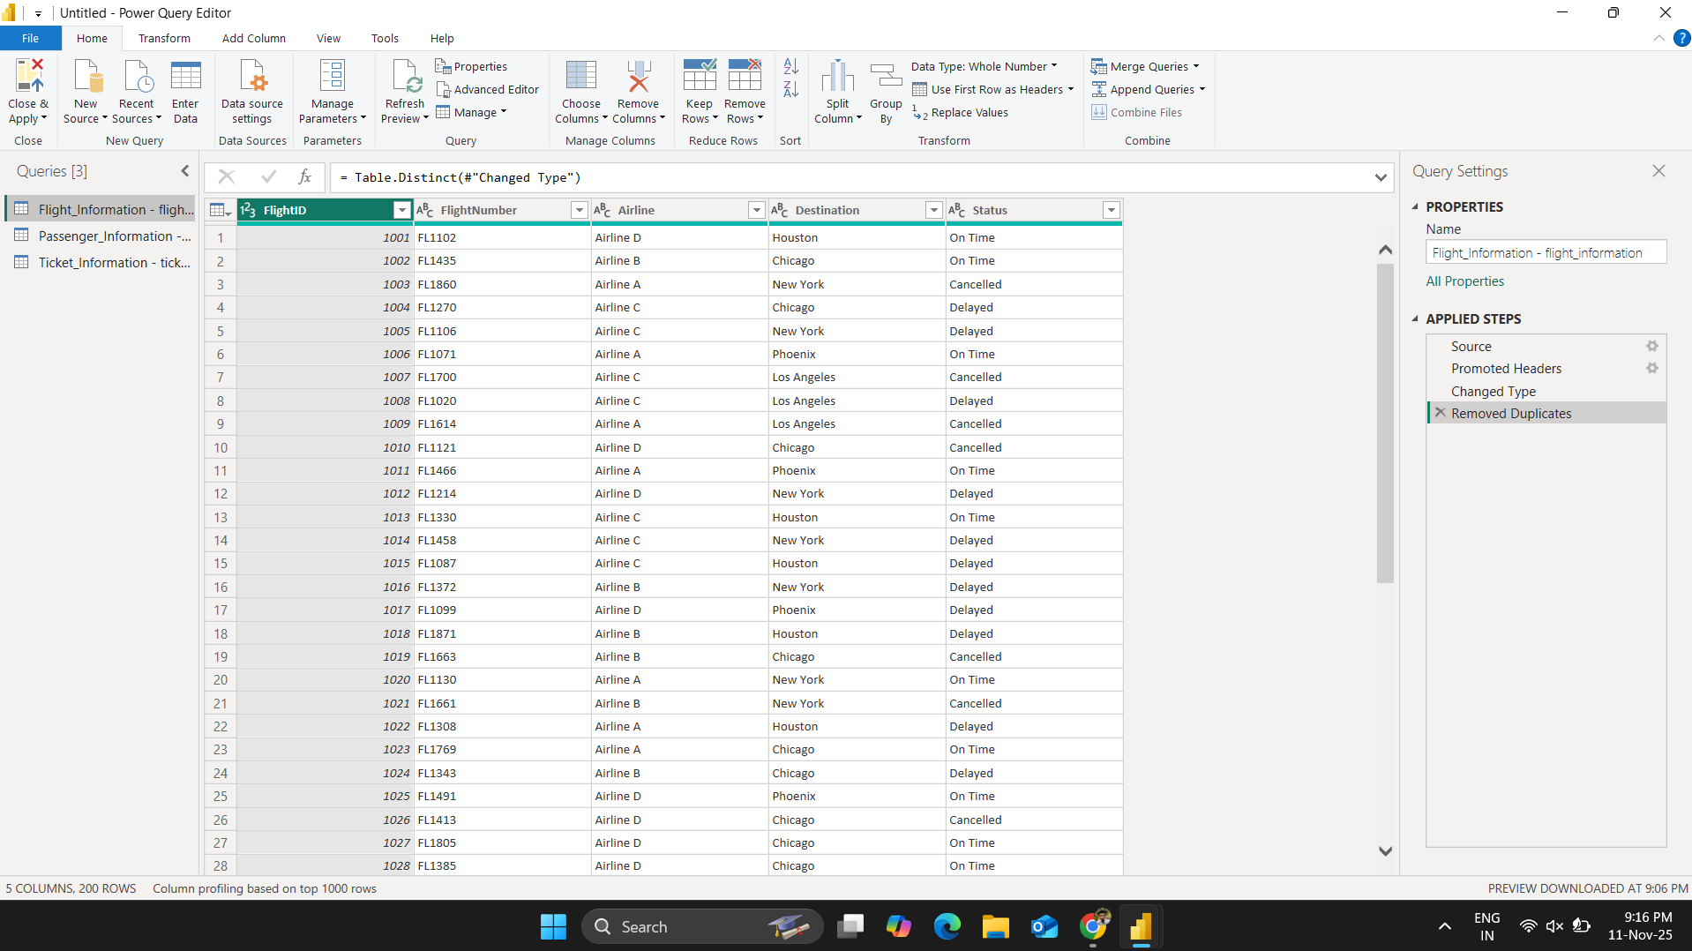

Fig. Screenshot_1

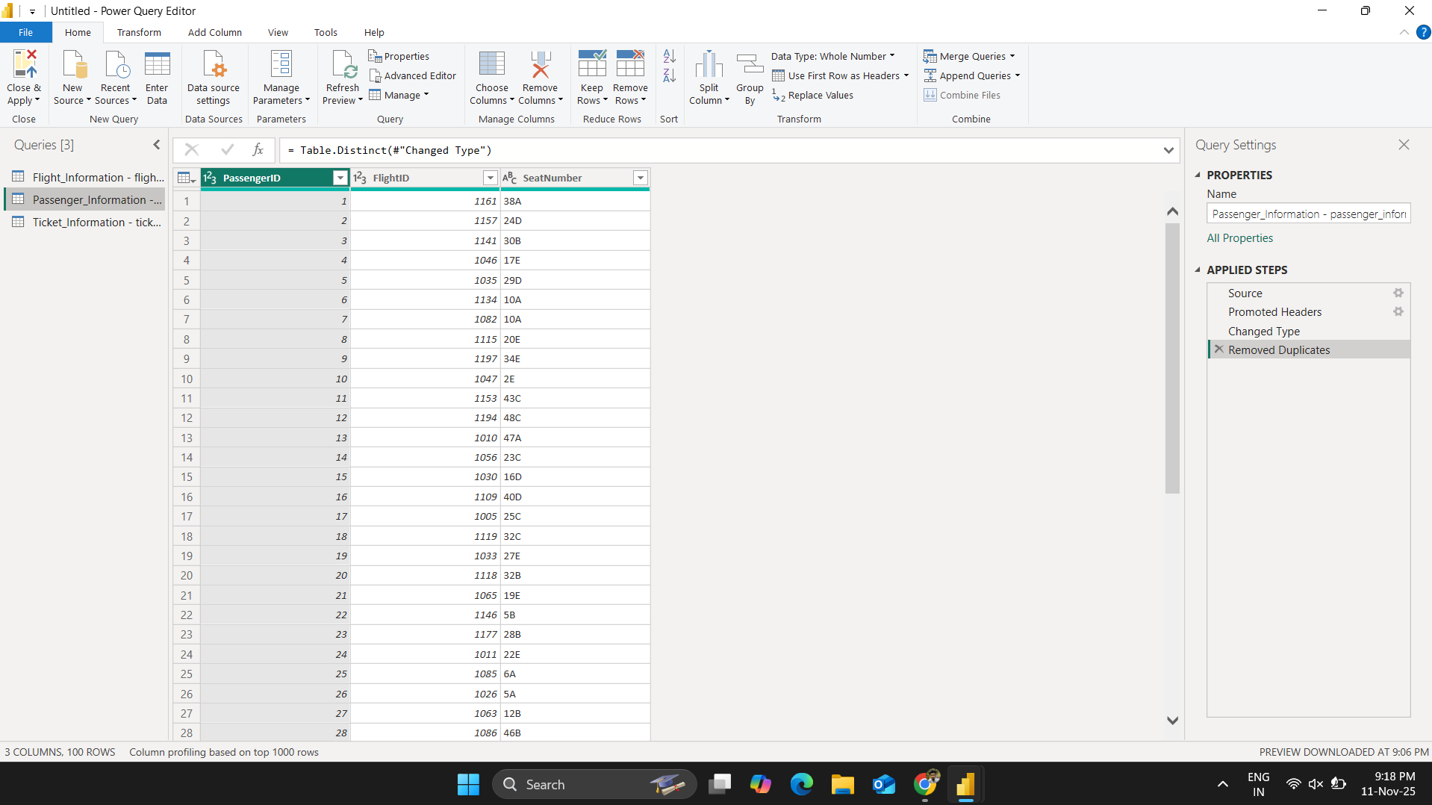

Fig. Screenshot_1.2

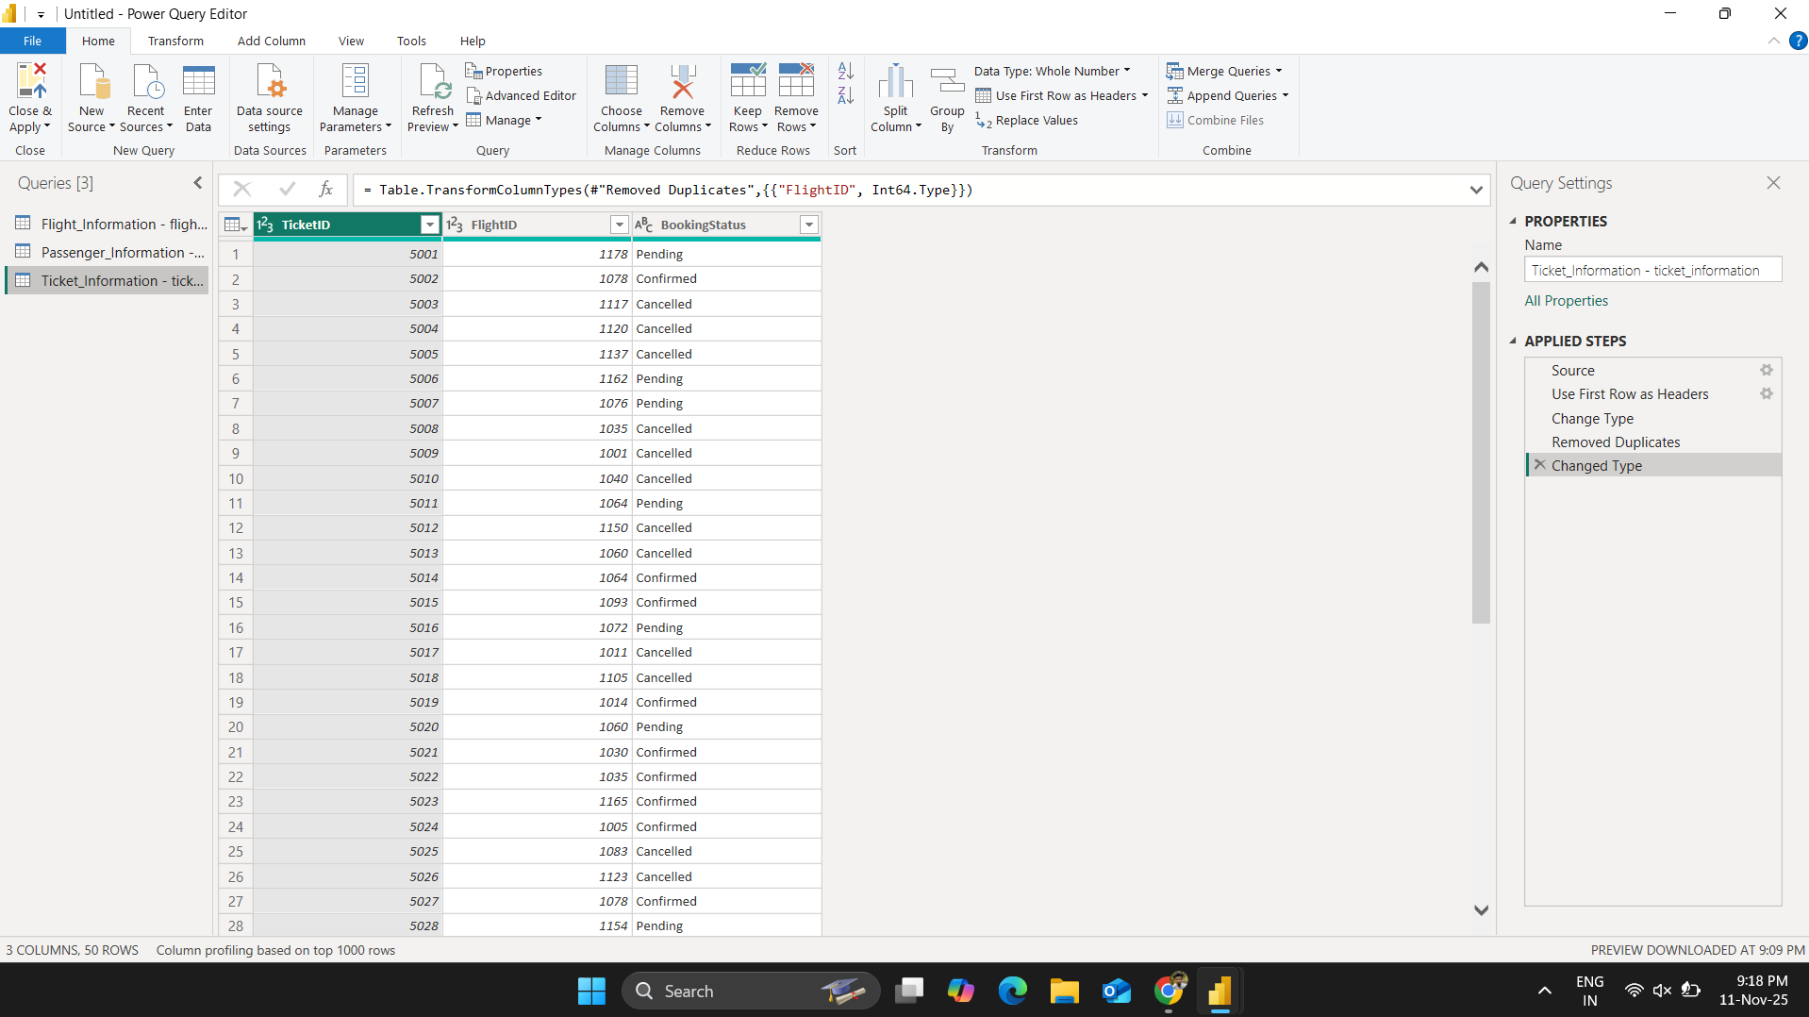

Fig. Screenshot_1.3

Task 2 - Data Modeling:
- Created relationships between Flight, Passenger, and Ticket tables using FlightID as the key.

Screenshots:

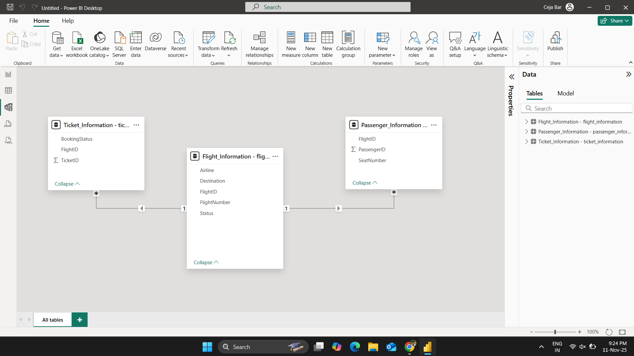

Fig. Screenshot_2

Task 3 - Enhanced Data Insights:
- Added an extra column named “Flight_Classification” to classify flights as "Best" or "To Be Improved" based on status.
- Extracted numeric part of flight number from “FlightNumber” column in “Flight_Information” table using ‘Column from Examples’ option.

Screenshots:

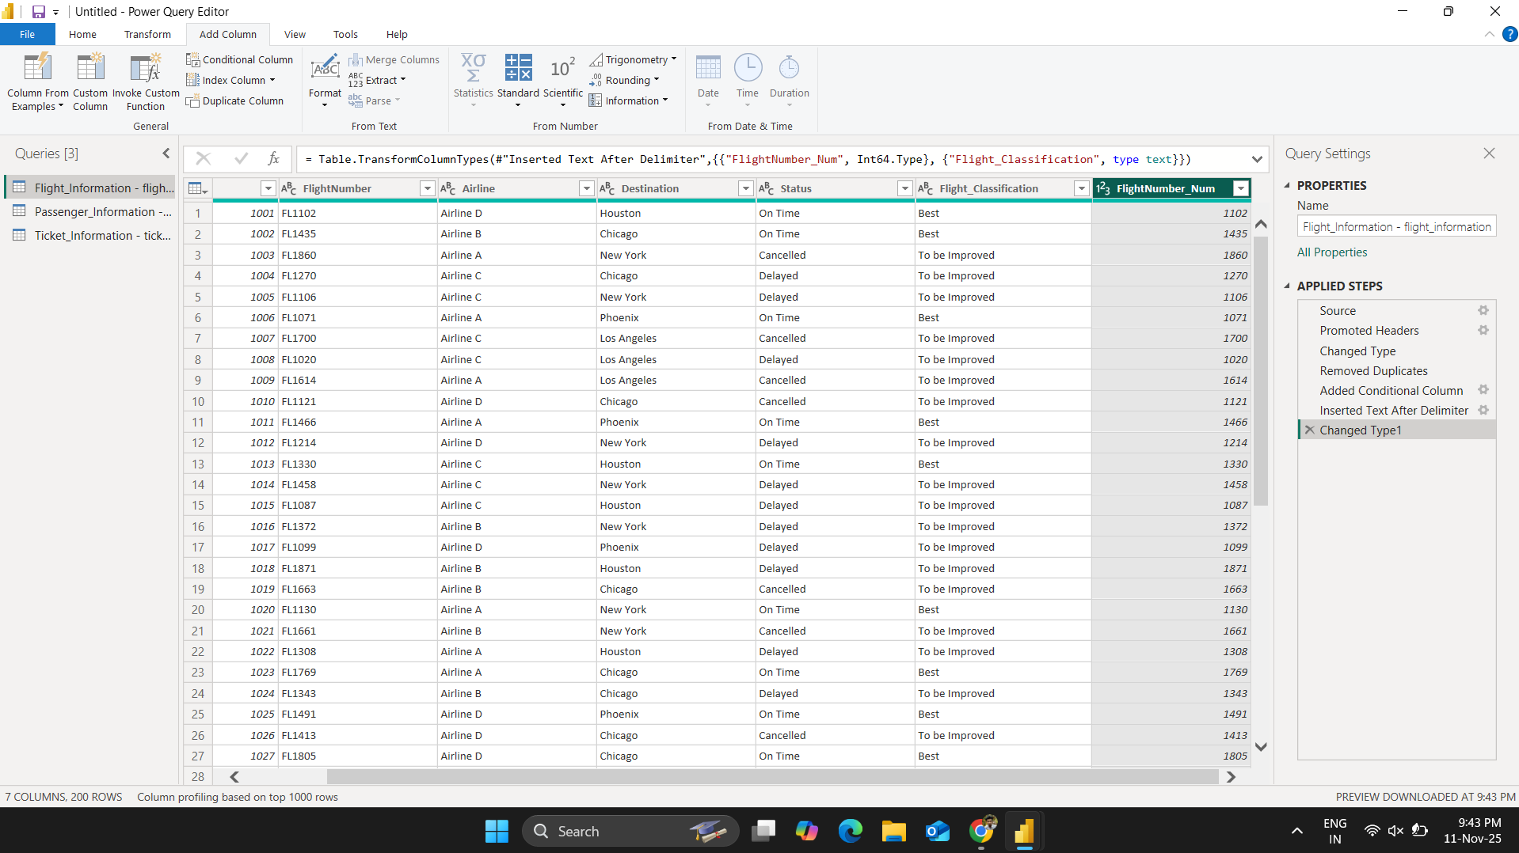

Fig. Screenshot_3

Task 4 - Calculations Using DAX:
- Created a measure to calculate Total Passengers.
- Total Passengers = COUNT(Passenger_Information[PassengerID])
- Created a measure to calculate Total Tickets Booked.
- Total Tickets Booked = COUNT(Ticket_Information[TicketID])
- Created a new filtered table showing only flights classified as “Best”.
- Best Flights = FILTER(Flight_Information,Flight_Information[Flight_Classification] = "Best")

Screenshots:

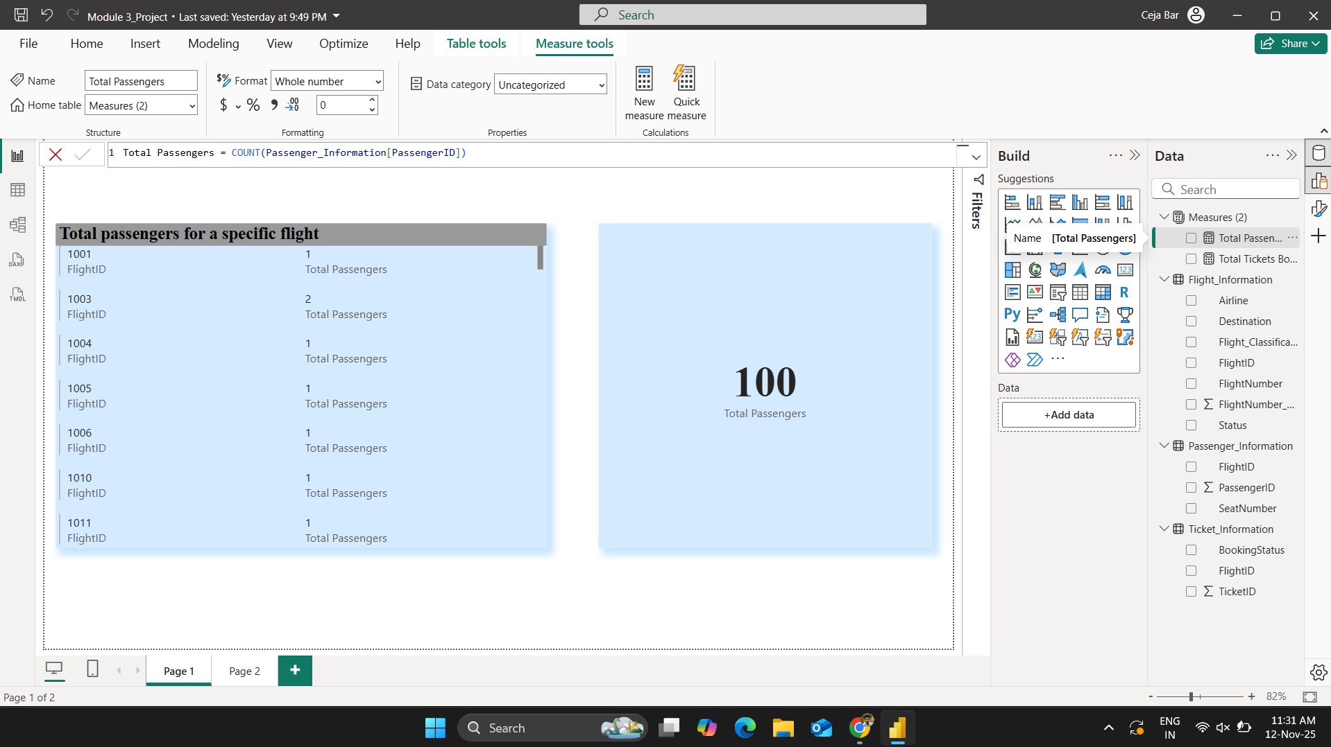

Fig. Screenshot_4

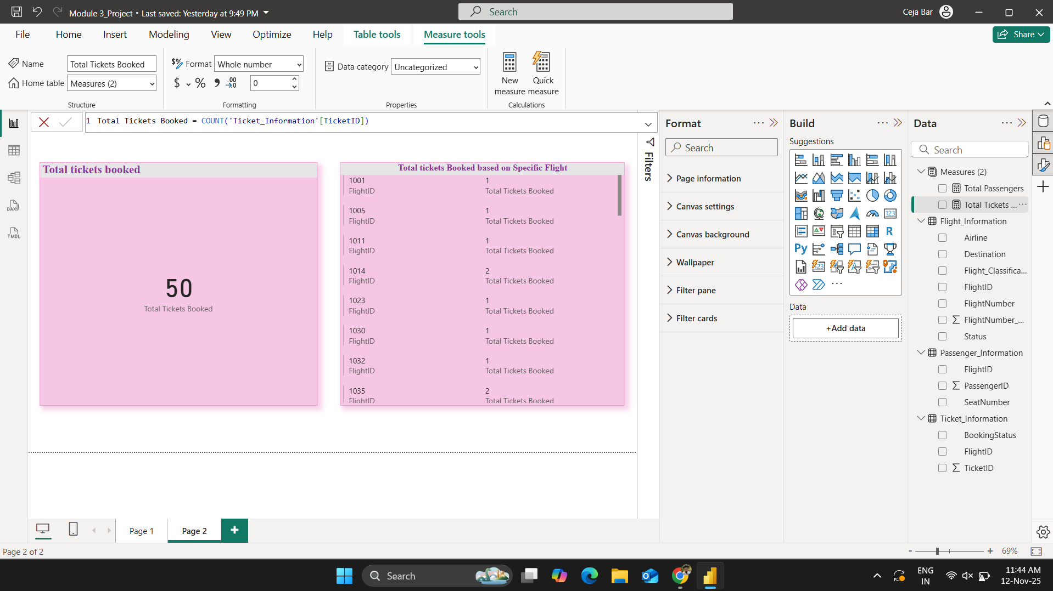

Fig. Screenshot_4.2

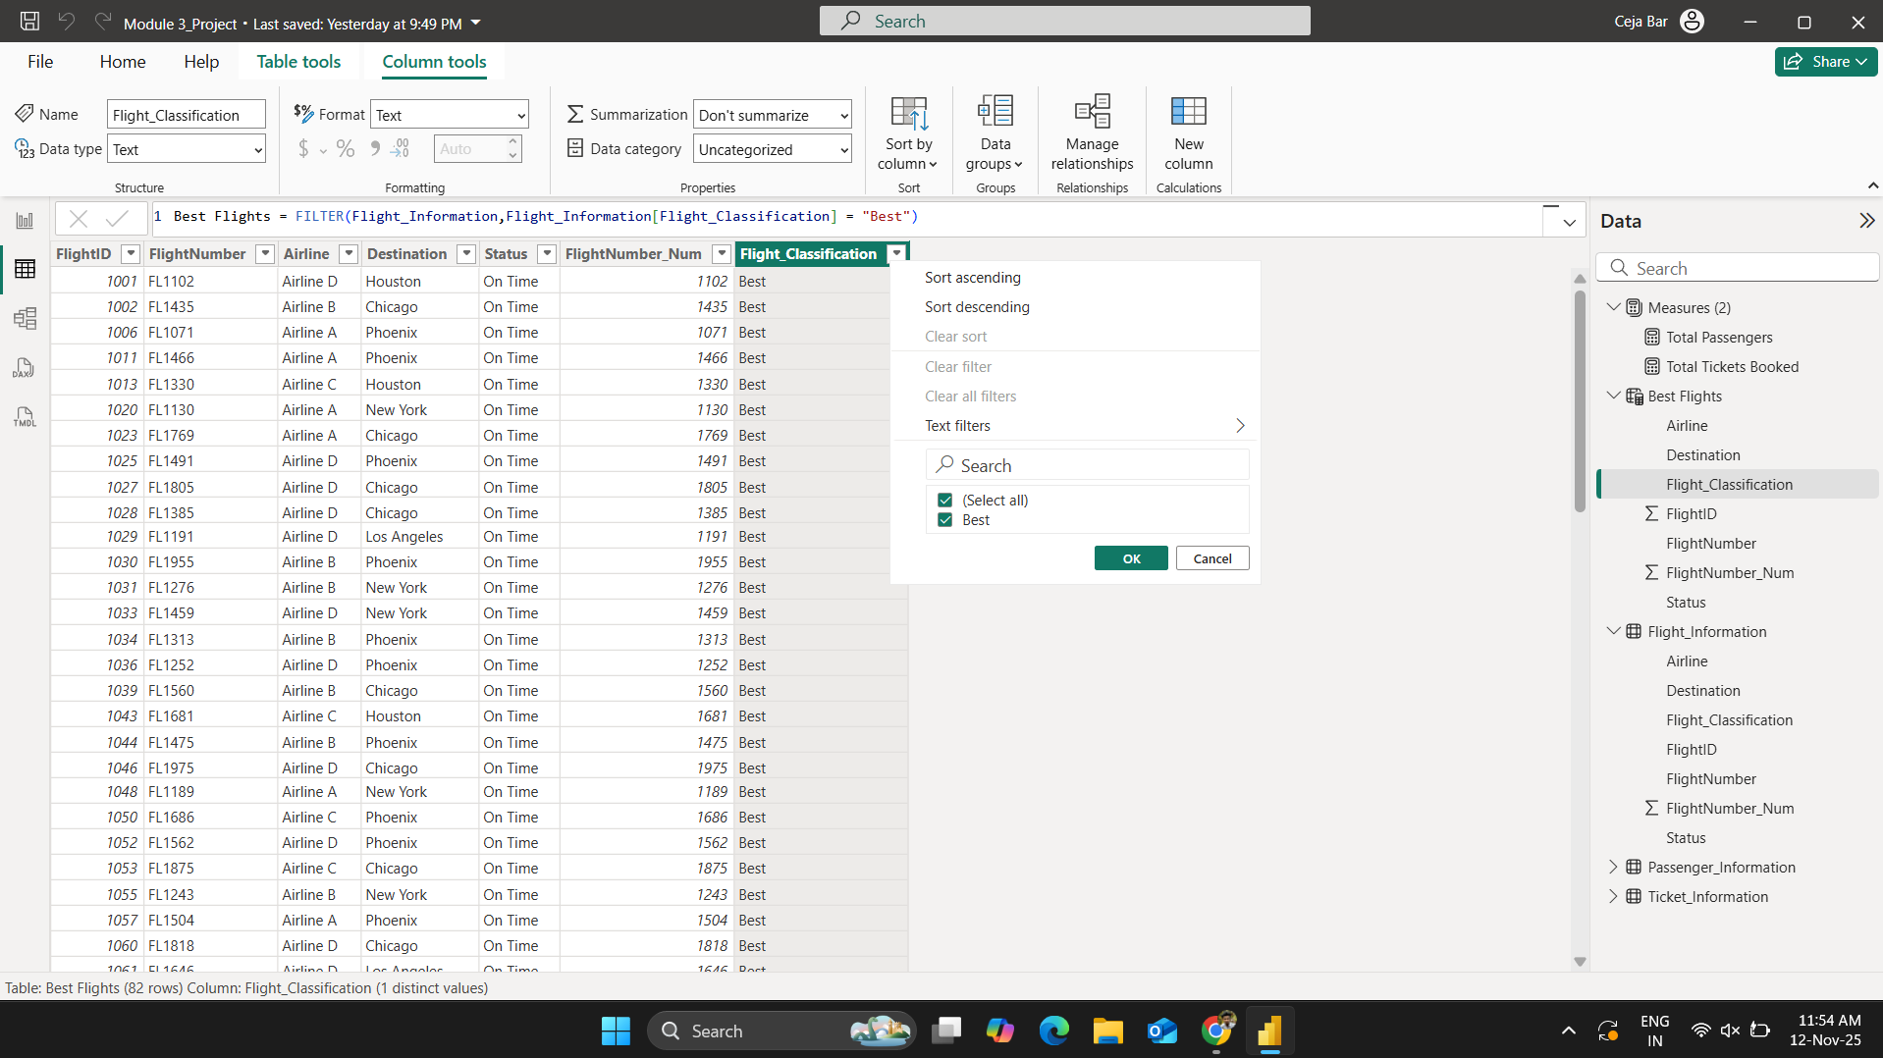
Fig. Screenshot_4.3

Task 5 - Visualization and Interactive Features:
- Created multiple visuals for:
  - Passenger Count by Airline.
  - Ticket Booking Status.
  - Flights by Airline & Destination.
- Added slicers, drill-through, and navigation buttons, etc.

Screenshots:

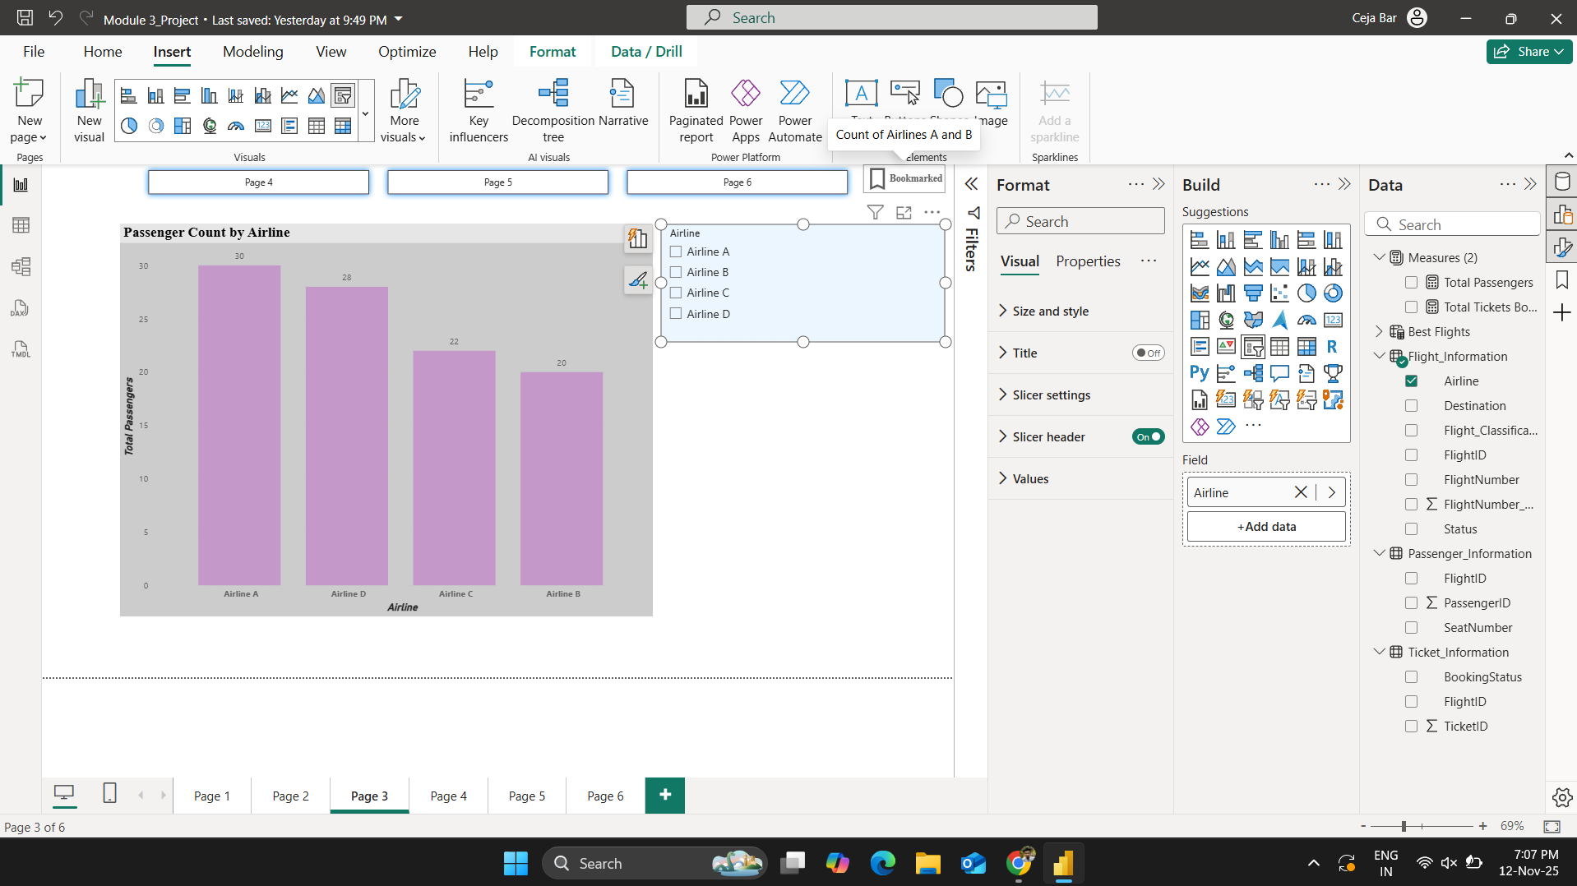

Fig. Screenshot_5

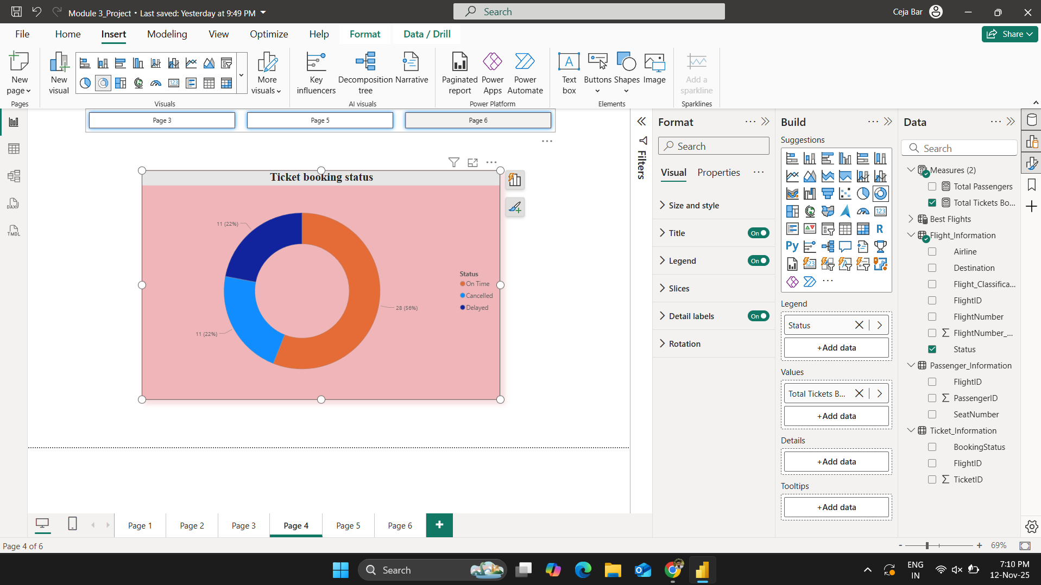

Fig. Screenshot_4.2

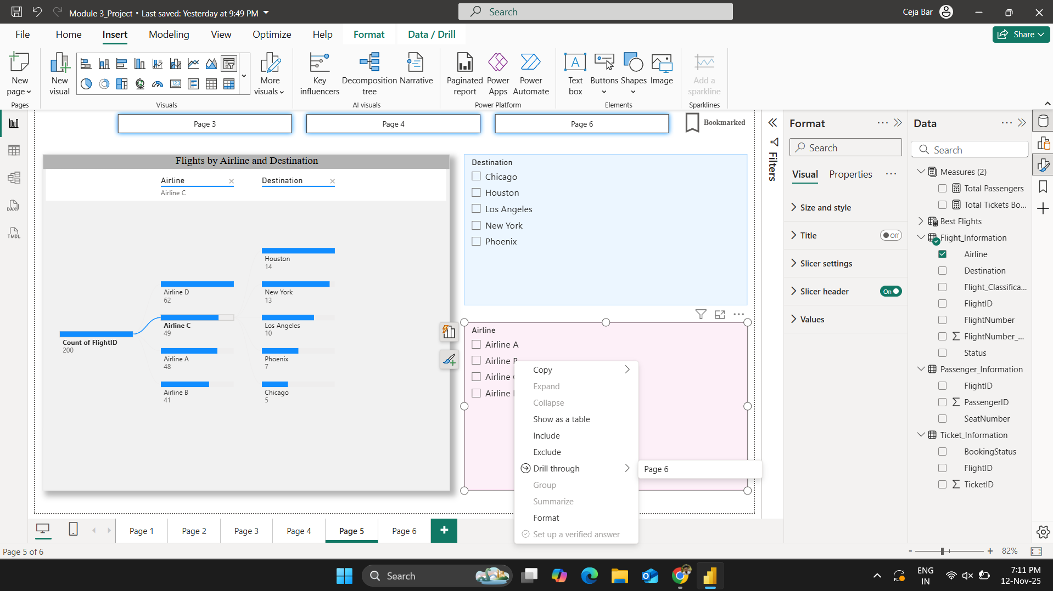

Fig. Screenshot_4.3

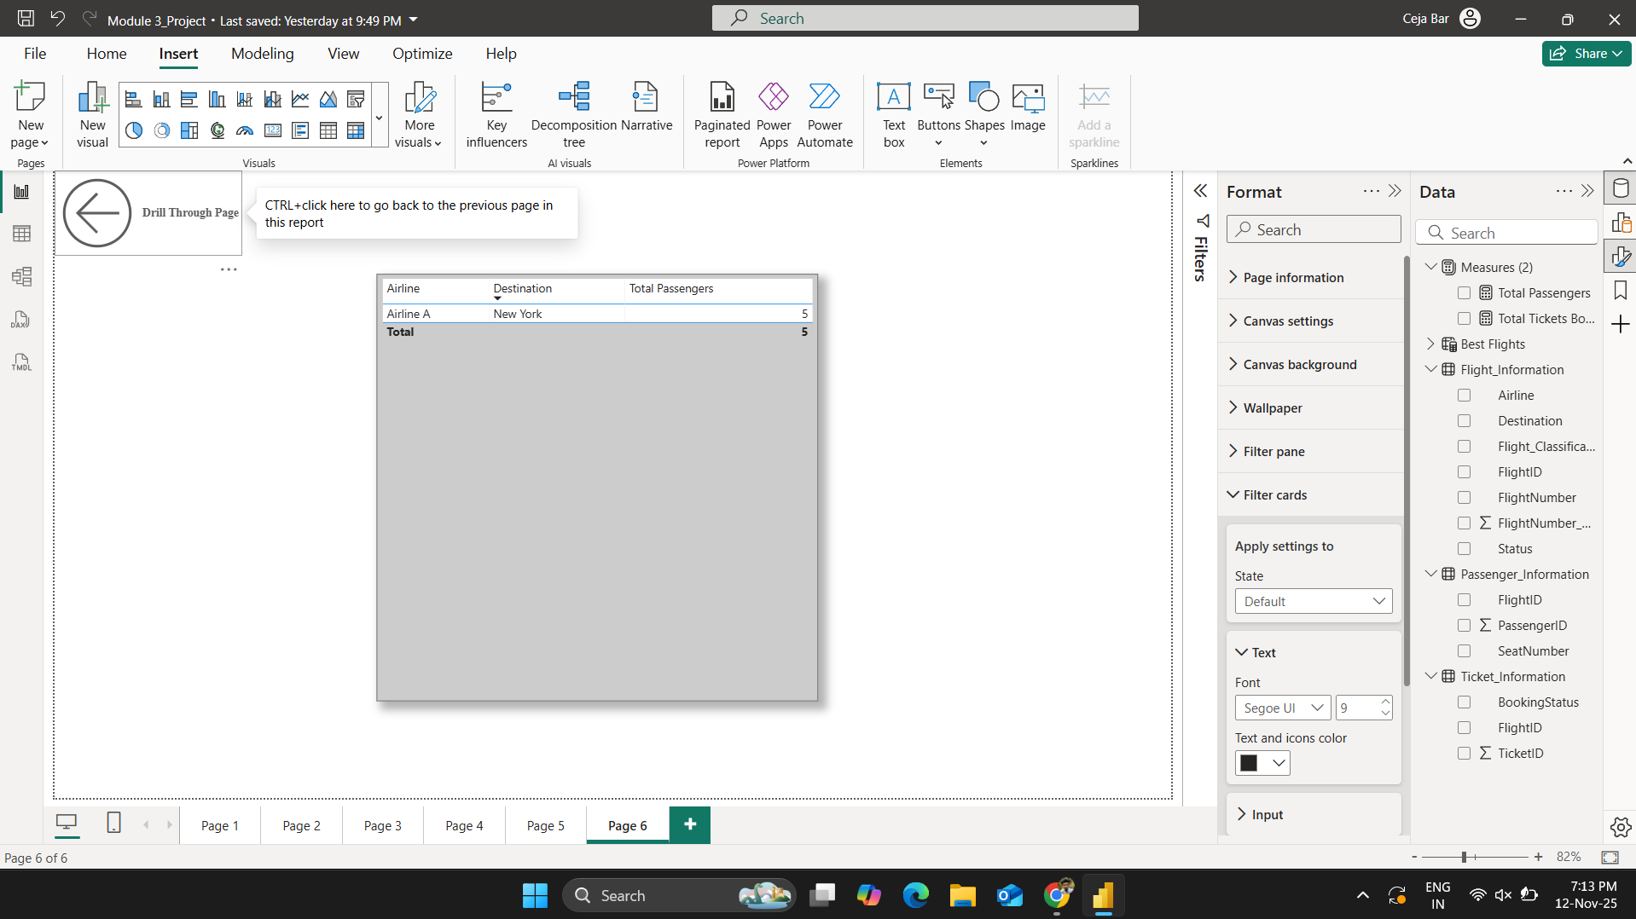

Fig. Screenshot_4.4

Task 6 - Final Dashboard and Power BI Service:
- Published the report to Power BI Service.
- Used “Pin to Dashboard” option to create main dashboard.
- Configured RLS for ‘Airline A’ data and assign it to a user.
- Scheduled daily refresh at 5 PM.
Screenshots:

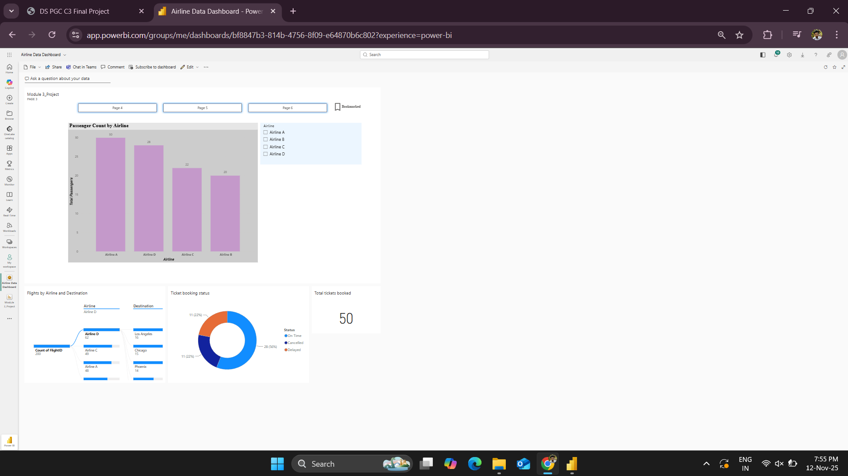

Fig. Screenshot_6

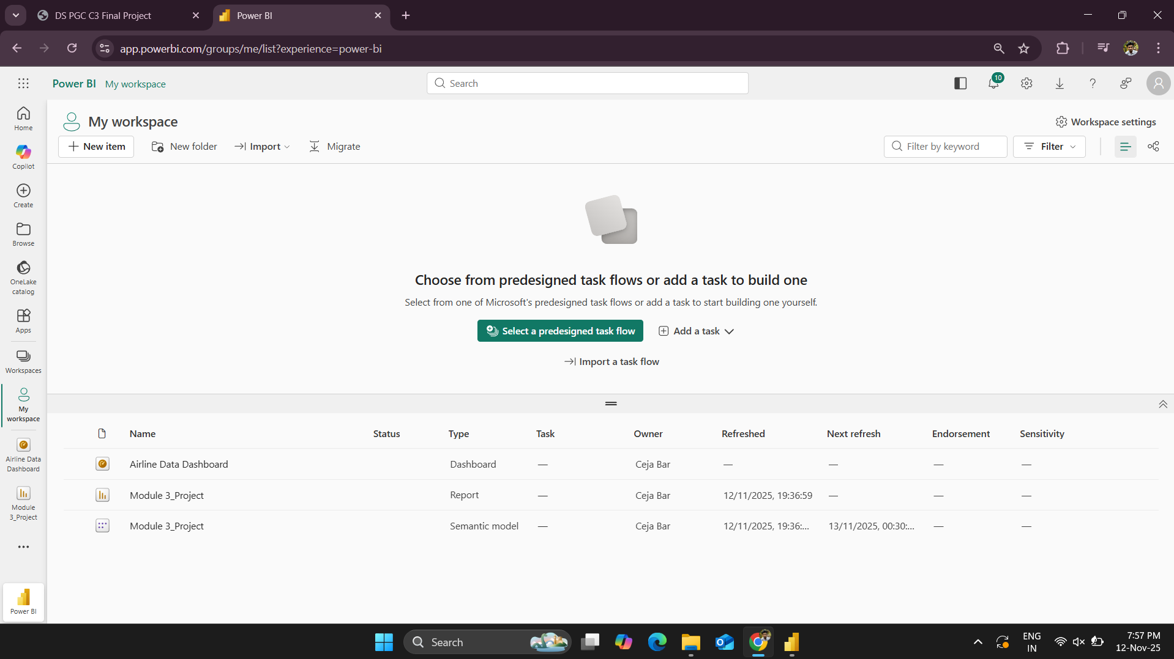

Fig. Screenshot_6.2

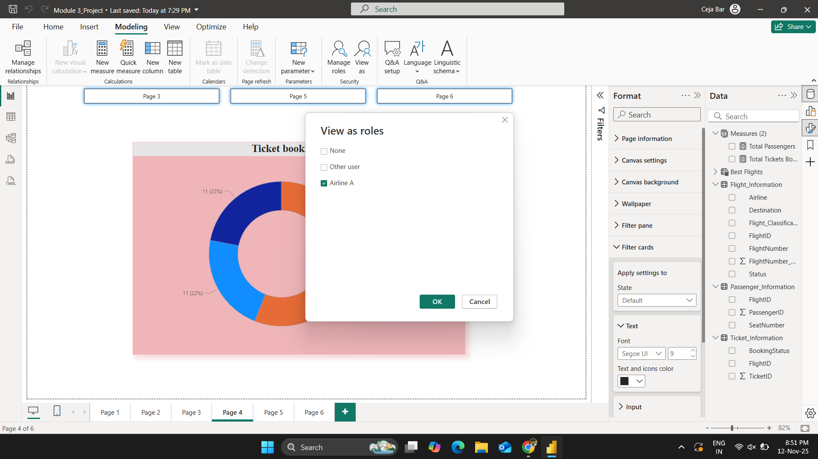

Fig. Screenshot_6.3

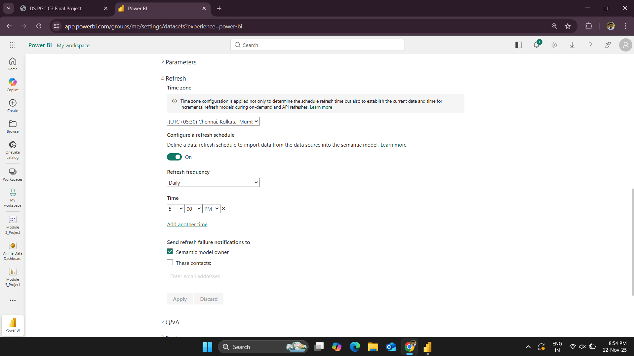

Fig. Screenshot_6.4

Key Findings and Insights

- ‘Airline D’ consistently performed well compared to other Airlines, both in total passengers and on-time flight performance.
- This concludes that “Airline D’s” operations are well managed and popular among passengers.
- Airline B and C have struggled the most which includes higher flight delays and cancellations.
- The data shows strong passenger flow toward major cities like ‘New York’ and ‘Los Angeles’ making them high demand destinations.
- The majority of bookings were confirmed and cancellations were mainly with poor flight status, indicating operational issues which directly impact ticket trends.
- The ‘Best’ flights mostly belong to airlines with better consistency and efficient route management whereas the airlines classified as ‘To Be Improved’ had delays, cancellations, and inconsistent operations.
- Implementing Row-Level Security(RLS) made sure that each airline had access only to its own data where confidentiality matters.
- The interactive dashboard simplifies data analysis for airline management.

Project Video Link:
https://www.loom.com/share/a755db8877894a6f98d658707a959575

